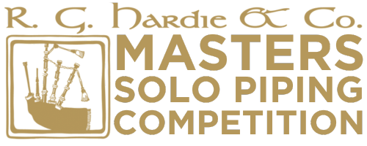

R.G. Hardie & Co. Masters’ Solo Piping Competition

At Piping Live! 2026 on
Sunday 9th August 2026

Piobaireachd | March, Strathspey & Reel
Starting time TBC | Starting time TBC
The Auditorium | The Auditorium
The National Piping Centre | The National Piping Centre
Glasgow | Glasgow
Prize Money | Prize Money
1st - £500 2nd - £350 3rd - £200 4th - £150 5th - £100 | 1st - £350 2nd - £200 3rd - £150 4th - £100 5th- £75
An overall trophy will be presented to the piper with the highest aggregate points. Piobaireachd will take preference in case of a tie. The winner of the MSR section will be presented with the Willie Beveridge Memorial trophy.

The overall winner will qualify for the Glenfiddich Piping Championship 2026 and a place at the Sunbelt Invitational Competition 2026.
ENTRY FORM
To be returned by post or email to Wilson Brown
themasters@thepipingcentre.co.uk
The National Piping Centre, 30-34 McPhater Street, Glasgow, G4 0HW

PAYMENT
An entry fee of £20.00 per event to be remitted by PayPal at time of entry to: tuition@thepipingcentre.co.uk

Closing Date for Entries – Thursday 25th June 2026

Name: | Tel:
Address:
Email Address:

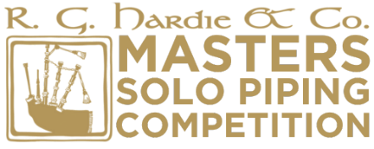
Name of Piper: ___________________________________________________

Piobaireachd (entry fee £20)
Open to competitors who have previously won the Gold Medal at The Argyllshire Gathering or The Northern Meeting

Competitors are to submit 4 Piobaireachds – one of which will be selected to play.

Competitors will be informed of their draw and selected tune at least two weeks in advance.

1. | 2.
3. | 4.

March, Strathspey & Reel (entry fee £20)
Open to competitors who are eligible to compete in the Former Winners MSR at The Argyllshire Gathering and The Northern Meeting

Competitors are to submit 4 Marches, 4 Strathspeys and 4 Reels – one of each will be selected to play, once through.

Competitors will be informed of their draw and selected tunes at least two weeks in advance.

Marches

1. | 2.
3. | 4.

Strathspeys

1. | 2.
3. | 4.

Reels

1. | 2.
3. | 4.

Both the Piobaireachd and the MSR competitions will be Livestreamed and by submitting an entry form you agree to have your performance filmed and broadcast.

